Problems with Using Dry Ice to Process/Transport Biomaterials
Maria Thompson August 21, 2014 Problems with Using Dry Ice to Process/Transport Biomaterials2014-08-21T09:18:51-07:00 Featured, Protocols, sample handling No Comment
Have you ever measured the temperature of a typical Styrofoam box with dry ice? We did. It’s not as cold as you think. Valuable biological samples handled in this manner are at risk of unnecessary warming events that might alter them in unknown ways.
Styrofoam Box with Dry Ice: Provides less than 1 inch depth < -50˚C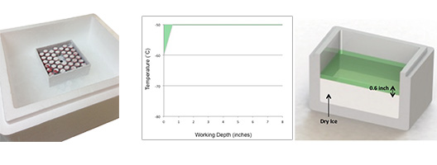
BioT™ ULT Transporter: Provides 8 inches depth < -50°C
A breakthrough in ultra-low temperature sample handling and transport, BioT ULT Transporter provides 8 inches of < -50°C working depth. That’s enough space to keep up to 8 standard 2-inch cryogenic storage boxes and their valuable contents safely below -50°C for hours. 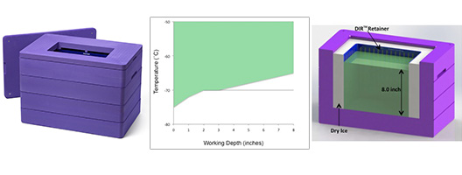

BioT™ ULT Transporter

< -70°C to -50°C temperature stability system
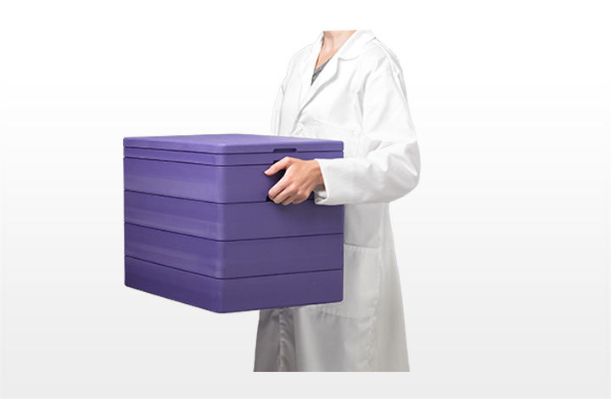
BioT™ ULT Transporter is a breakthrough portable solution for handling and transporting valuable temperature-sensitive biomaterials. It may also be used for freezing samples at a collection site.
- Stays between < -70°C and -50°C for over 24 hours  - Keeps up to 8 standard 2-inch cryostorage boxes below -50°C  - Lightweight, built-in finger grips for easy carrying  - Intuitive assembly, highly durable materials | 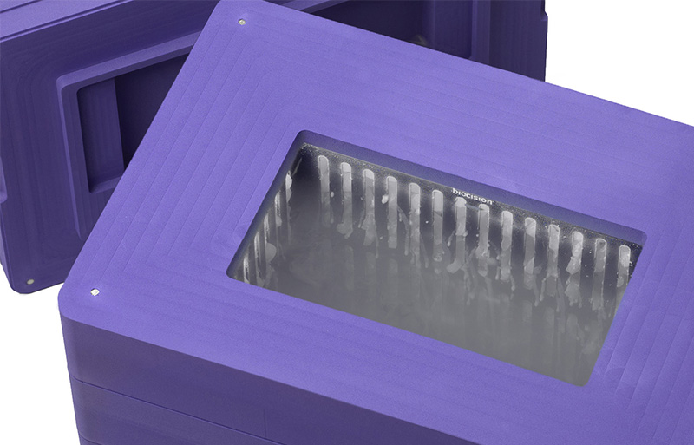
Temperature and duration:
Temperature Range | Cooling Source | Cooling Duration  Open Lid | Cooling Duration  Closed Lid
<-70˚C to -50˚C | Dry Ice | Over 8 hours | Over 24 hours
Far superior to Styrofoam box and dry ice, a method commonly used for processing and transporting valuable biological samples and other temperature-sensitive biomaterials, BioT™ ULT Transporter ensures all contents remain below -50°C for 8 hours with lid open, and over 24 hours with lid closed.
Styrofoam and Dry Ice: Not as cold as you think
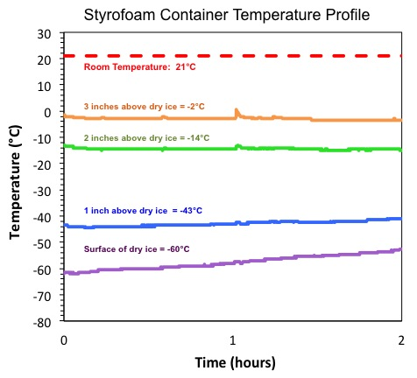 | Temperature profile in the “Cooled Volume” of a 7 in deep Styrofoam container filled half full with dry ice. Only the bottom 0.6 inches of the freezer box are in the desired < -50°C region (green shading). The top of the freezer box (and sample tubes or vials inside) is at -14°C. 20 min after adding dry ice (to reach equilibrium), temperature readings were taken at 0, 1, 2, and 3 inches above the dry ice for 2 hours.  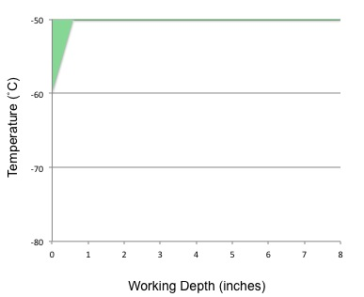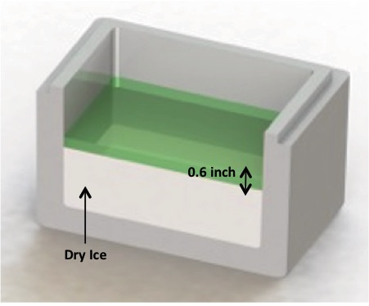Only 0.6 inch (1.5 cm) above the dry ice stays below -50°C for 2 hours. At 2 inches (5.0 cm) above the dry ice - the top of a standard 2-inch cryostorage box - the temperature is already at -14°C.
BioT™ ULT Transporter: Over 8 inches depth < -50°C, 8 hours with lid open, 24 hours lid closed
Lid open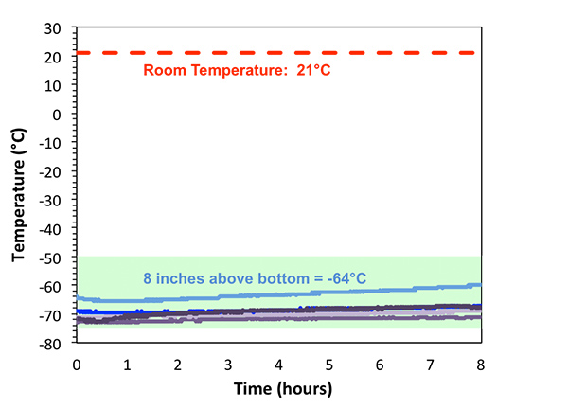  Lid closed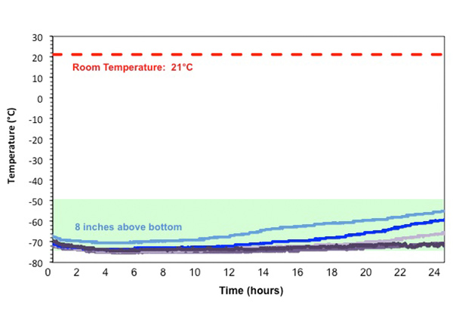 | Temperature profile of BioT™ ULT Transporter loaded with dry ice and with lid open. The entire 8 inch working depth of the transporter remains below -50°C (green shading) for over 8 hours with one charge of dry ice and with the lid open. Temperature readings were taken every 2 inches above the chamber floor for 8 hours. Inches above base chamber floor: 0 inches (dark purple), 2 inches (purple), 4 inches (lavender), 6 inches (dark blue), 8 inches (light blue).  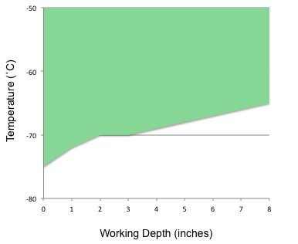  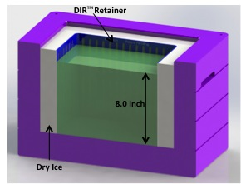BioT ULT Transporter provides a depth of 8 inches (20 cm) below -50°C. Up to 8 standard 2-inch cryostorage boxes and their valuable contents can safely stay under -50°C for over 8 hours with the lid open, and over 24 hours with lid closed

How it works  BioT™ ULT Transporter is comprised of four parts: magnetized lid, magnetized collar, DIR™ dry ice retainer, base chamber.  The patent-pending DIR™ cooling insert technology inside the transporter harnesses cold convection for efficient, stable, and hours-long dry ice based cooling. Dry ice is added to the cavity between the DIR retainer and base chamber walls filling to the top of the retainer (5.4 kg, 12.8 lb). The ventilated thermo-conductive retainer ensures uniform and consistent gas circulation to keep the entire base chamber at ultra-low temperature. This configuration also minimizes consumption of dry ice as one charge maintains contents under -50°C for over 24 hours.  The closed-cell high-density polyethylene foam construction of the lid, collar and base chamber is durable, non-absorbent, and remains comfortable to the touch even when loaded with dry ice and frozen materials. The magnetized collar and lid ensure safe transport of the contents. The DIR™ retainer is constructed of a thermo-conductive aluminum alloy anodized for durability.  BioT™ ULT Transporter may be cleaned with bleach or alcohol solutions.  DIR retainer may be autoclaved or cleaned with alcohol or bleach. | 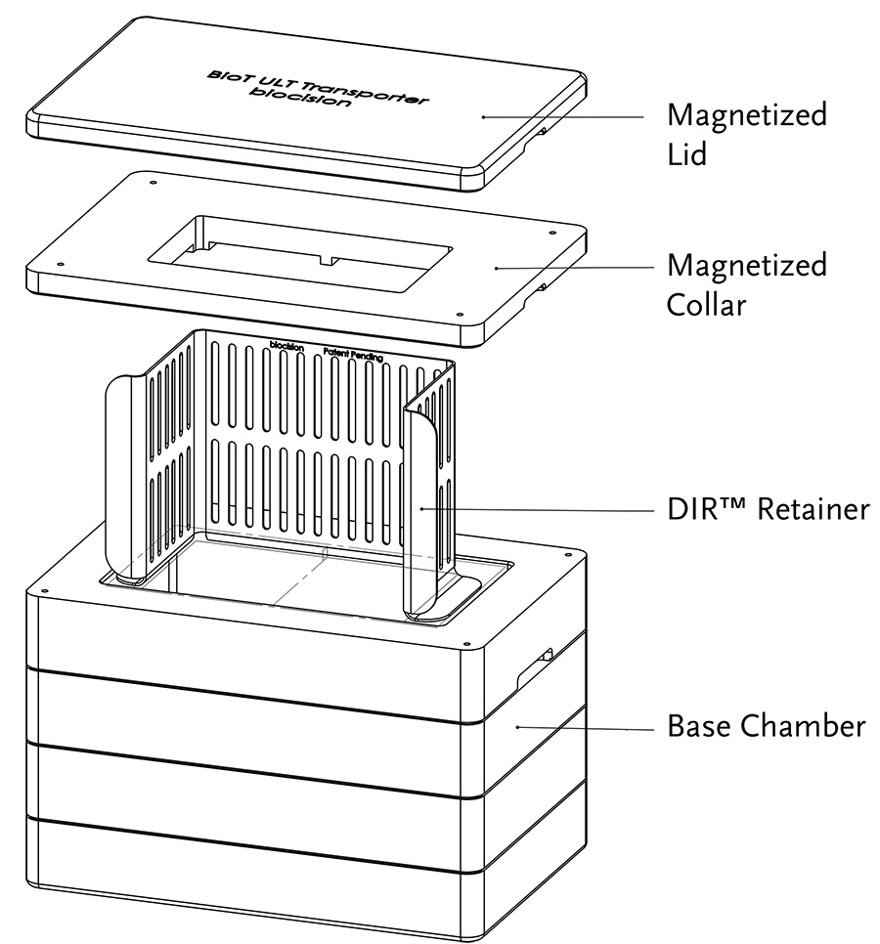
Applications
BioT™ ULT Transporter is a versatile ultra-low temperature system that maintains a stable < -70 to -50°C throughout its entire 8 inch working depth over an 8 hour period (with the lid off), enabling secure handling, freezing, and transfer of temperature-sensitive biomaterial. With the lid on, the transporter maintains < -70 to -50°C in the chamber for over 24 hours, enabling longer sample transport with virtually no temperature variation or risk of elevated temperatures that could compromise valuable biomaterials. The bottom 4 to 6 inches of the BioT™ ULT Transporter remain ≤ -70°C for hours, simulating an ultra-low freezer environment and allowing the collection and freezing of biological samples at collection site.
Other applications include:
- Cherry-picking, sorting or other short term handling of critical samples outside a -80°C freezer
- Controlled-temperature transfer of frozen samples between laboratories or collection and processing sites
- Transfer of temperature-sensitive materials to clinical sites or labs
- Freezing samples at collection site (in conjunction with CoolCell® cell freezing containers or CoolRack® thermo-conductive modules)
- Receiving or preparing frozen samples for shipment
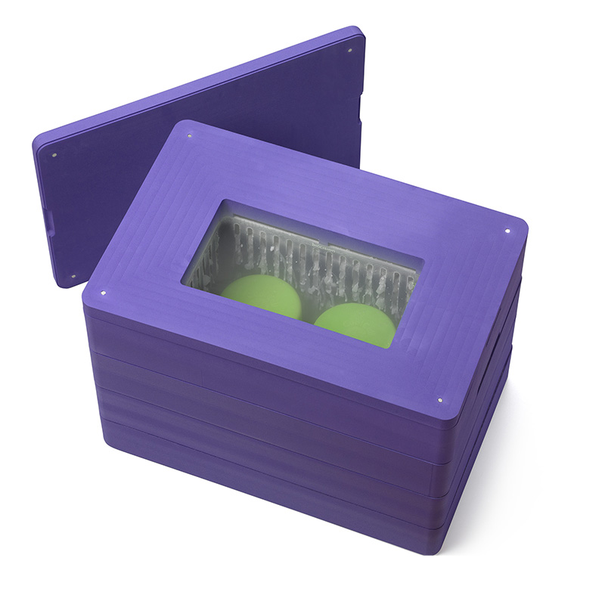 | 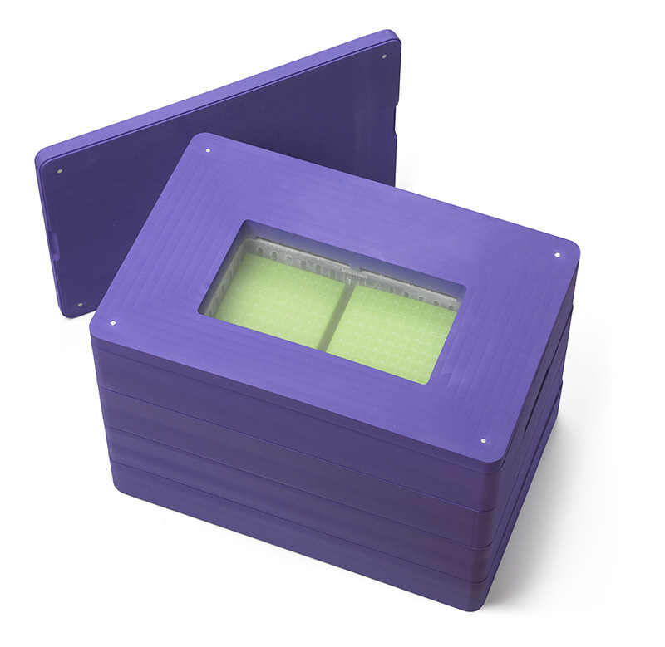
Specifications:
Hours of <-50˚C cooling | Lid off: over 8 hours
Hours of <-50˚C cooling | Lid on: over 24 hours
Amount of dry ice required | 5.4 kg (12.8 lb)
Weight empty | 3.6 kg (8.0 lb)
Weight with dry ice | 9.0 kg (20.8 lb)
Working depth < -50°C | up to 20 cm (8 in) from chamber floor
Capacity | 8 standard 2-inch cryostorage boxes

Dimensions (L x W x H)
Internal: 28.7 x 16.2 x 20.3 cm / 11.3 x 6.4 x 8.0 in
External: 50.8 x 33.6 x 37.4 cm / 20.0 x 13.3 x 14.8 in
Custom color options (green, pink, orange) are available with a minimum order quantity of 6 units.
BioT™ULT Transporter brochure
Instructions for use

